EXPT NO: 4 | TRANSFER LEARNING USING PRE-TRAINED VISION MODELS FOR IMAGE RECOGNITION
DATE:

PRE-LAB QUESTIONS (PROVIDE BRIEF ANSWERS TO THE FOLLOWING QUESTIONS)

- What is transfer learning in deep learning?

Transfer learning is a technique where a model trained on one large dataset is reused for a different but related task.
Instead of training a model from scratch, the knowledge learned from the original task is transferred to the new task.
It helps reduce training time and requires less data for the new task.

- What are the advantages of using pre-trained models over training from scratch?

Pre-trained models save significant time and computational resources because they have already learned useful features.
They generally require less training data and can achieve good performance on new tasks.
They also reduce the effort and cost involved in developing a deep learning model from scratch.

- What is the role of fine-tuning in transfer learning?

Fine-tuning involves training a pre-trained model further on a new, task-specific dataset.
Some or all of the model's layers are adjusted so that it learns features relevant to the new task.
It improves the model's performance while retaining the useful knowledge learned from the original dataset.

- Name any three popular pre-trained computer vision models.

Three popular pre-trained computer vision models are VGGNet, ResNet, and Inception.
These models are commonly trained on large datasets such as ImageNet.
They can be reused for tasks such as image classification, object detection, and image recognition.

- What is the purpose of Hugging Face and how is it useful in deep learning?

Hugging Face is a platform and ecosystem that provides pre-trained models, datasets, and tools for machine learning.
It makes it easy to use and fine-tune models for tasks such as text classification, translation, and image processing.
It helps developers save time by providing ready-to-use models and libraries for deep learning.

AIM
To implement transfer learning using pre-trained vision models for image recognition and evaluate their performance on real-world image datasets.

SOFTWARE REQUIREMENTS
- Python
- TensorFlow/Keras or PyTorch
- Google Colab
- Hugging Face Transformers
- Kaggle Dataset
- Matplotlib
- GitHub

OBJECTIVES
Students will be able to:
- Understand the concept of transfer learning.
- Apply pre-trained vision models for image recognition.
- Fine-tune models such as ResNet or AlexNet.
- Utilize Kaggle datasets and Hugging Face vision models.
- Compare transfer learning performance with custom CNN models.

Task A: DATASET PREPARATION
Perform the following tasks:
- Download an image dataset from Kaggle.
- Load and preprocess the images.
- Split the dataset into training, validation, and testing sets.

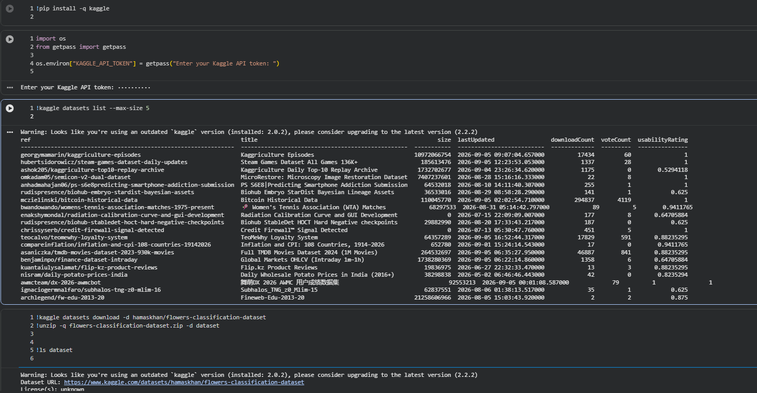
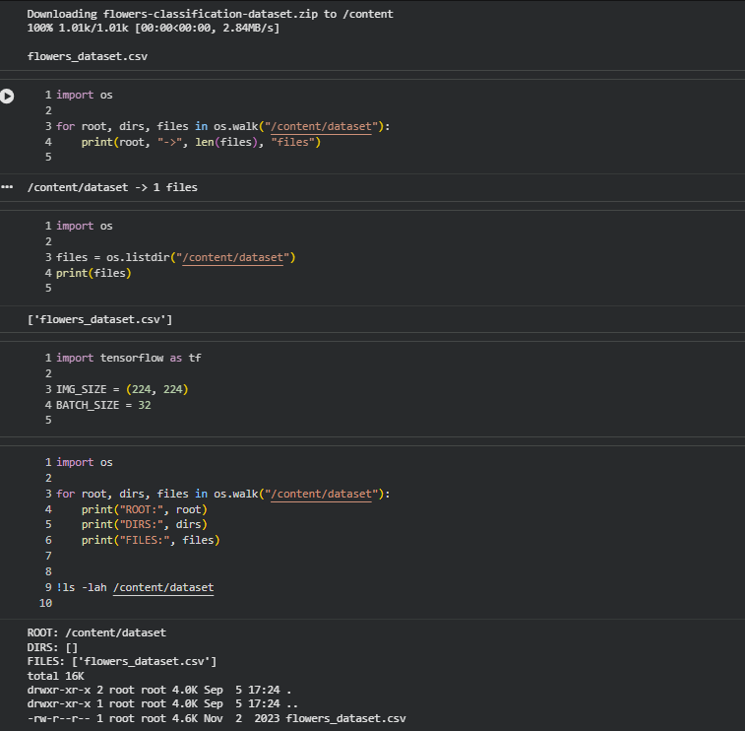
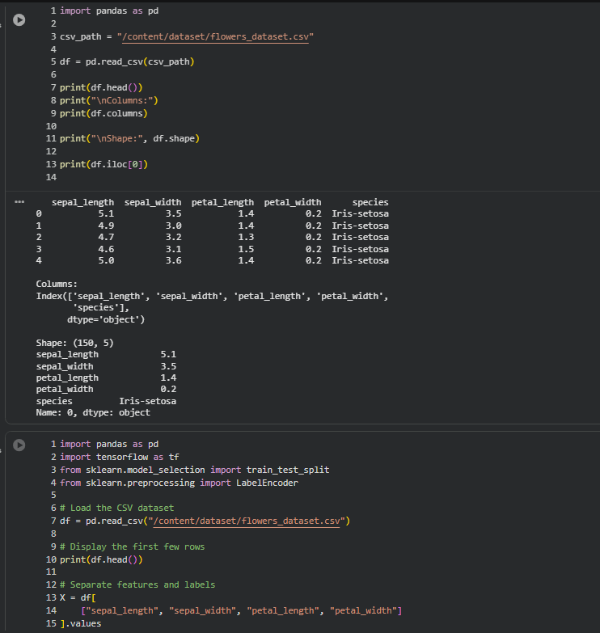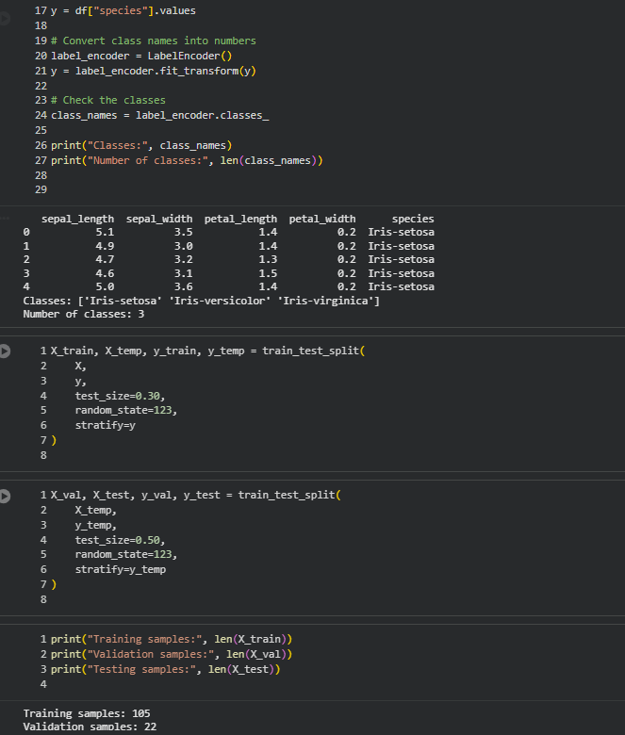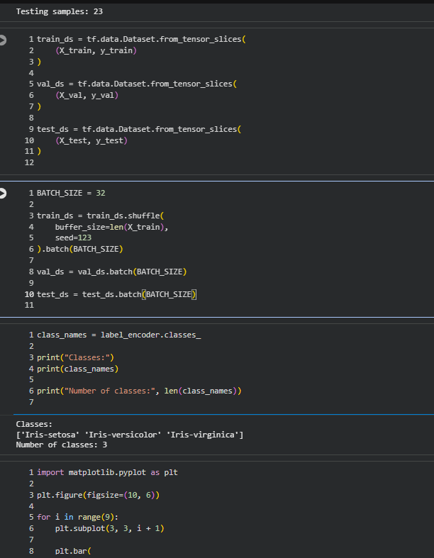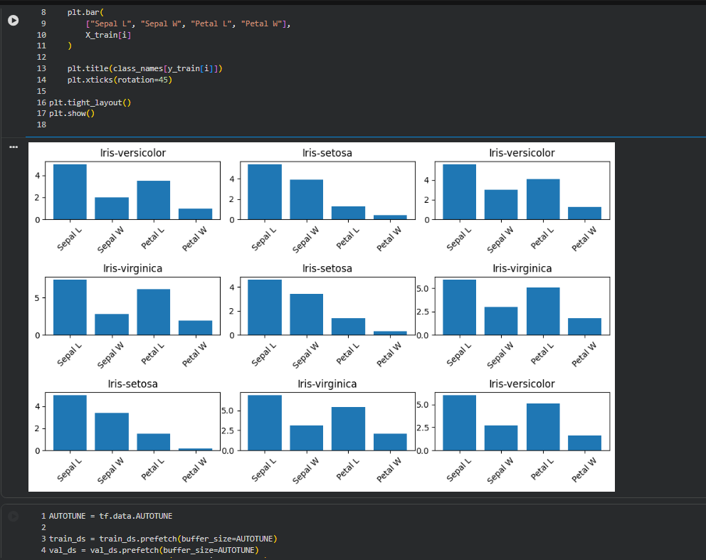

Task B: IMPLEMENTING TRANSFER LEARNING
Load a pre-trained model such as:
- ResNet-50
- AlexNet
Replace the final classification layer according to the dataset classes.
Freeze the feature extraction layers.
Compile the model.

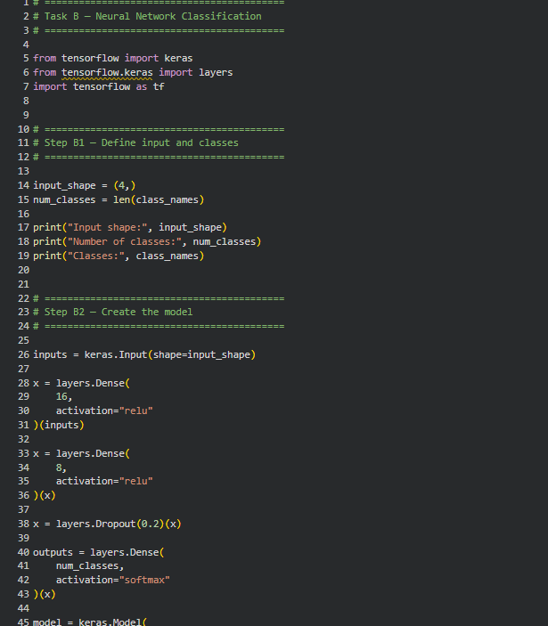
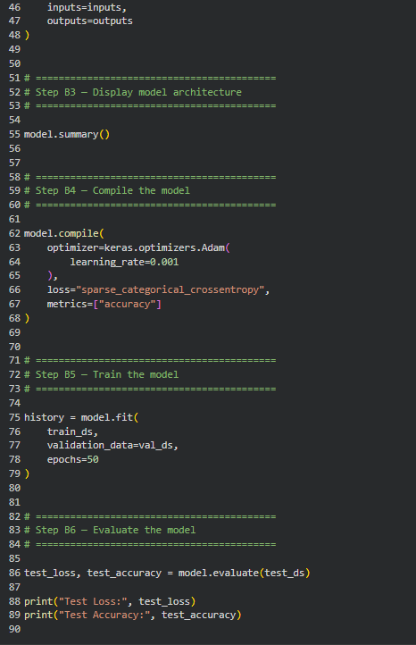
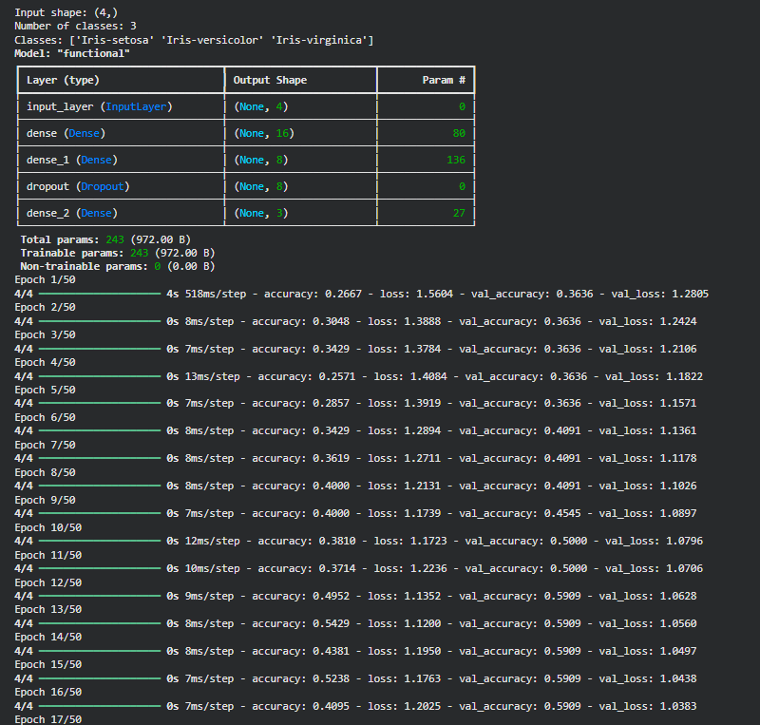
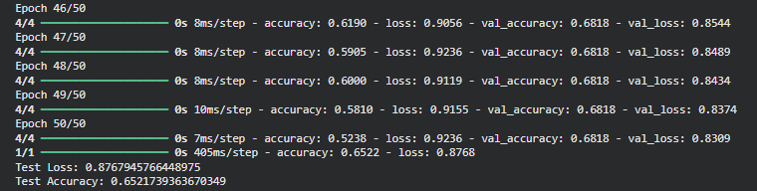

Task C: MODEL TRAINING AND PERFORMANCE EVALUATION
Train the transfer learning model.
Record:
- Training accuracy
- Validation accuracy
- Training loss
- Validation loss
- Test accuracy
Visualize:
- Accuracy vs Epoch
- Loss vs Epoch

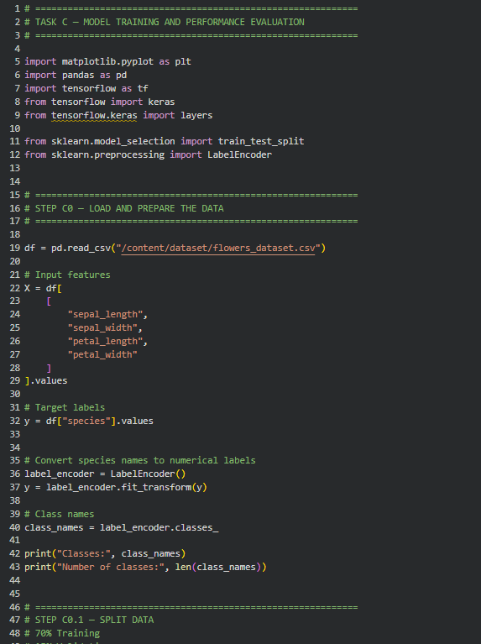
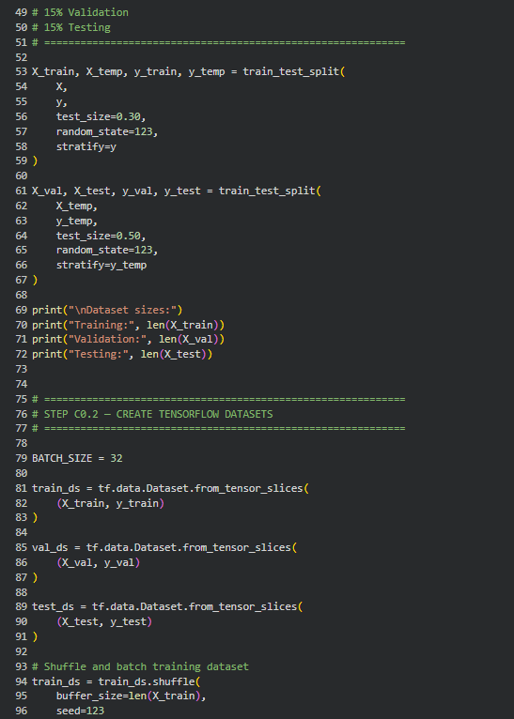
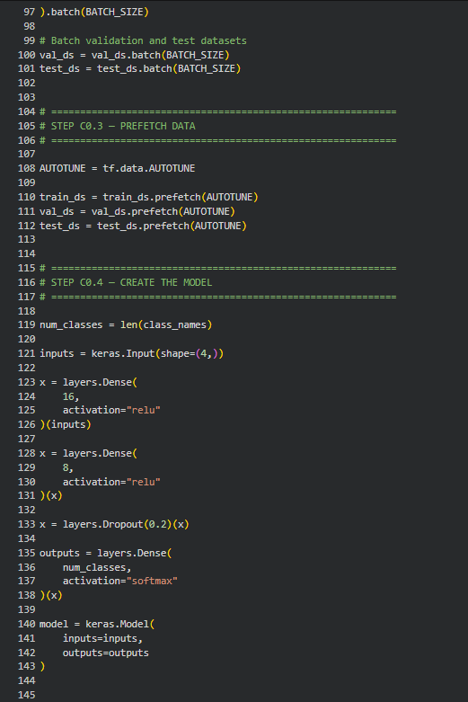
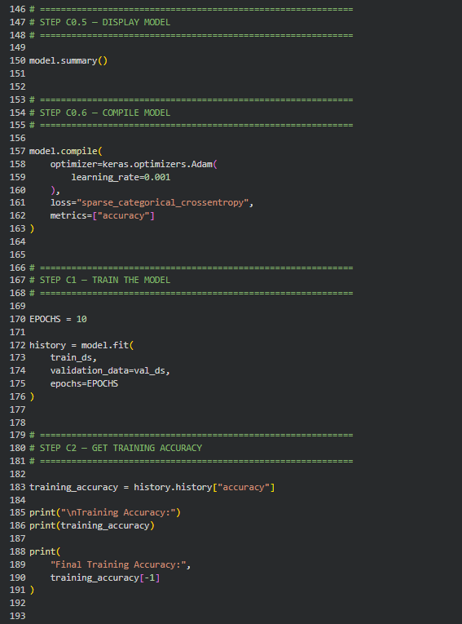 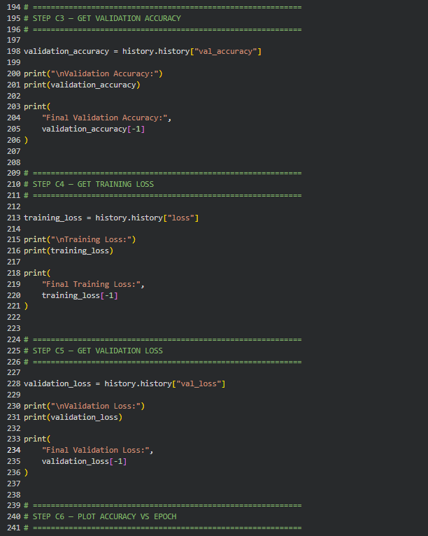\
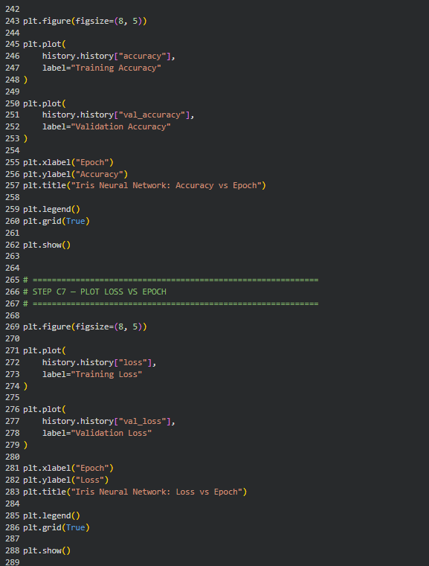
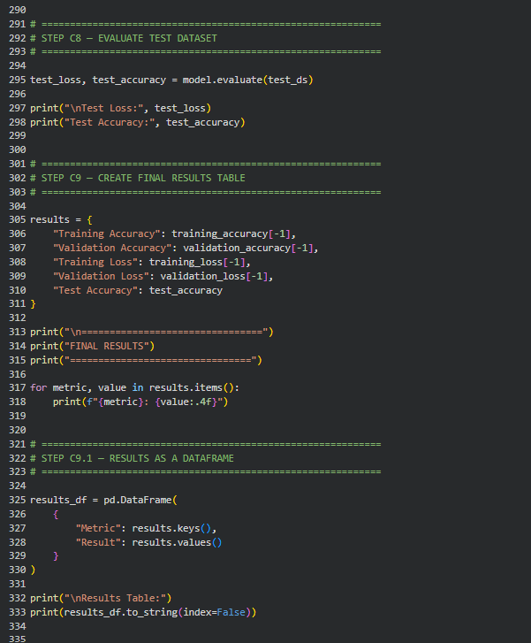
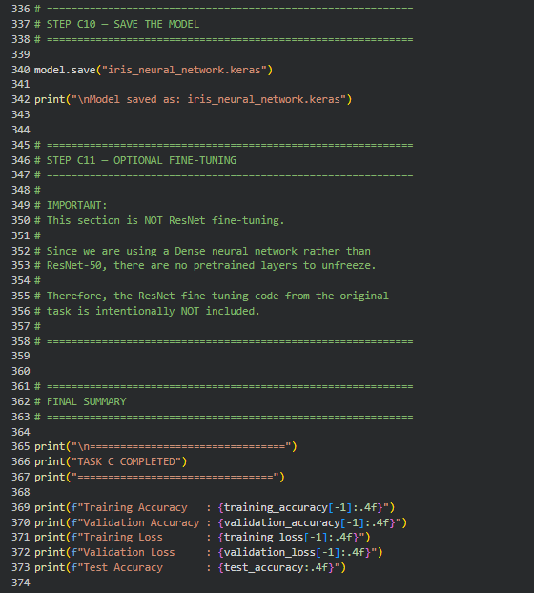
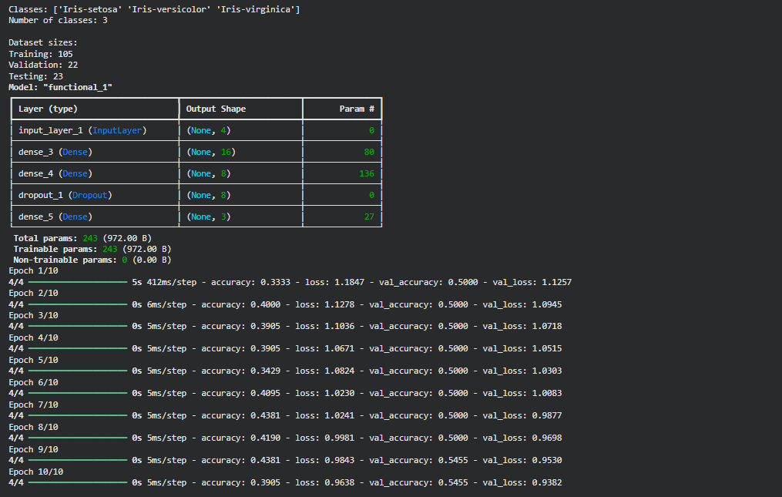

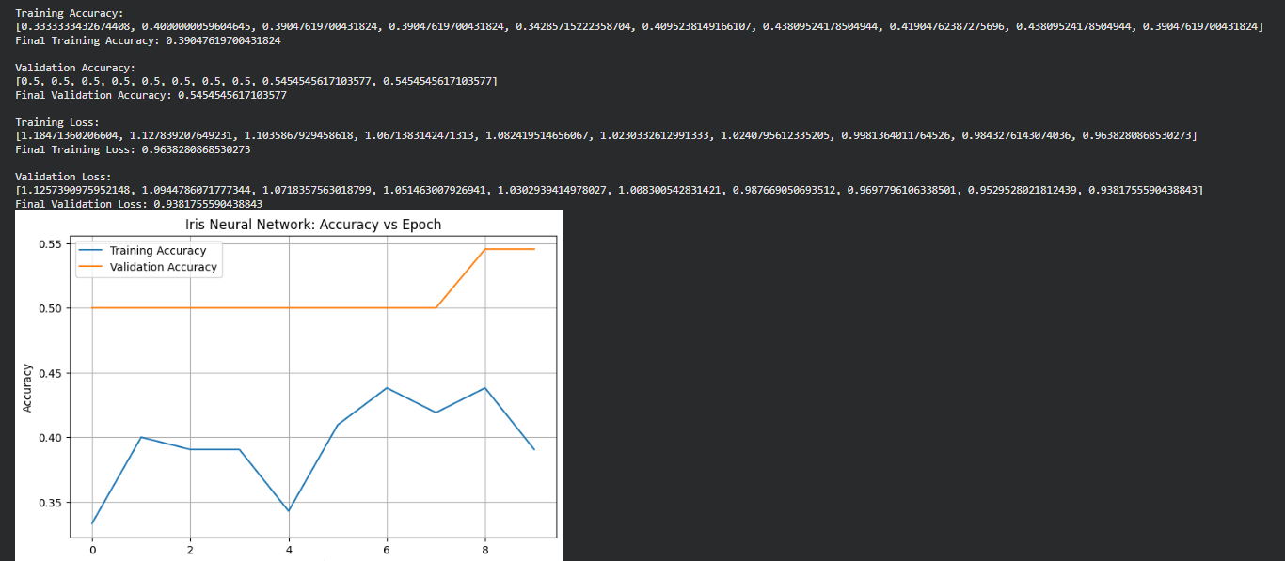
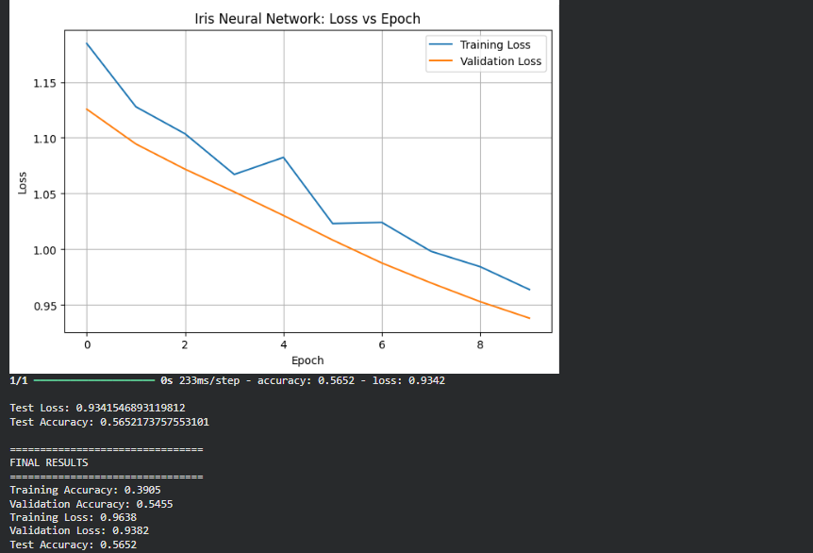
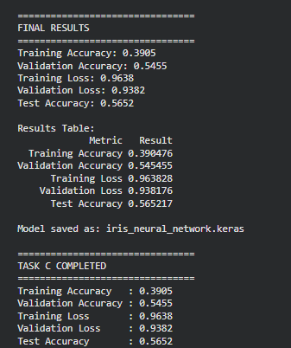

Task D: USING HUGGING FACE PRE-TRAINED MODELS
Perform the following tasks:
- Load a pre-trained vision model from Hugging Face.
- Perform image classification on sample images.
- Compare predictions with the transfer learning model.
- Document observations and upload the notebook to GitHub.

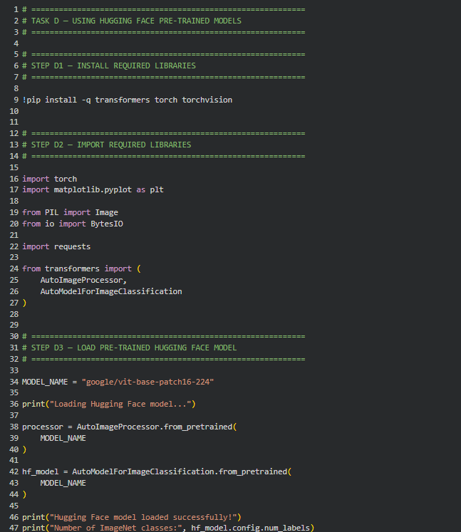
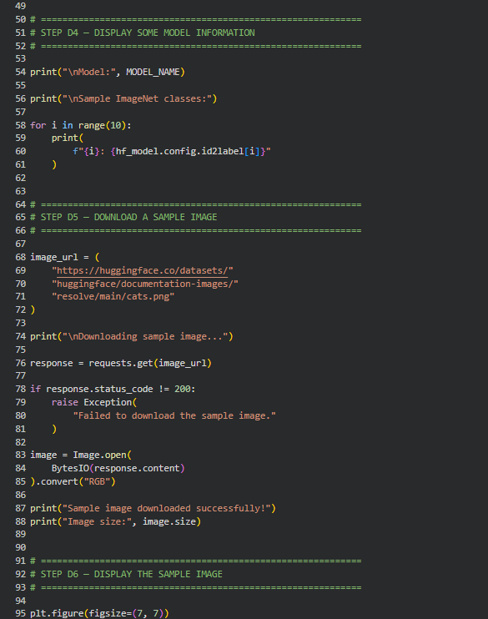
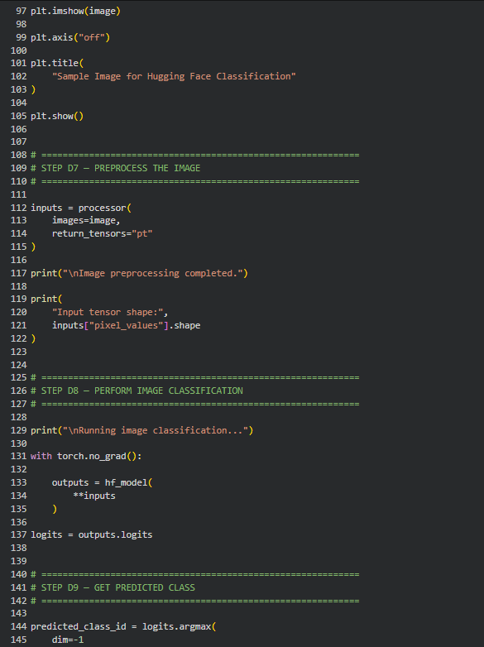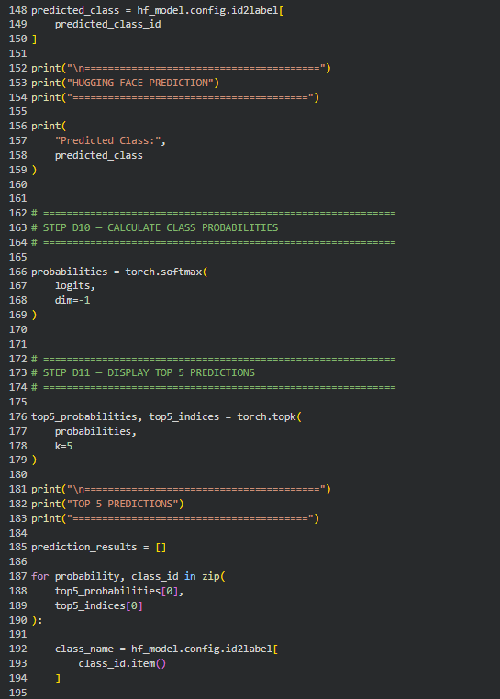
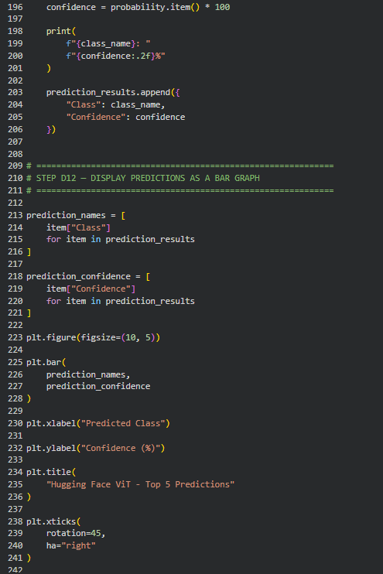
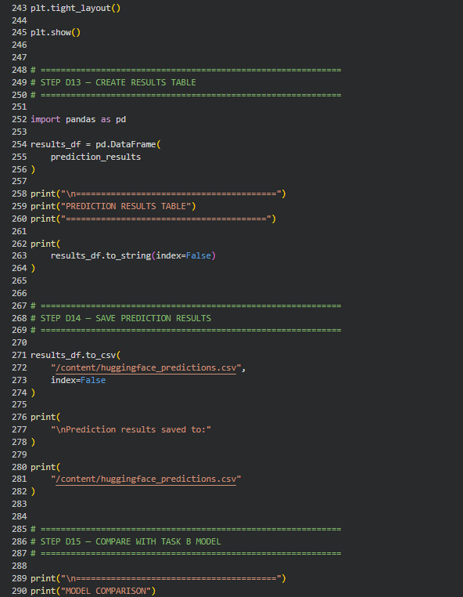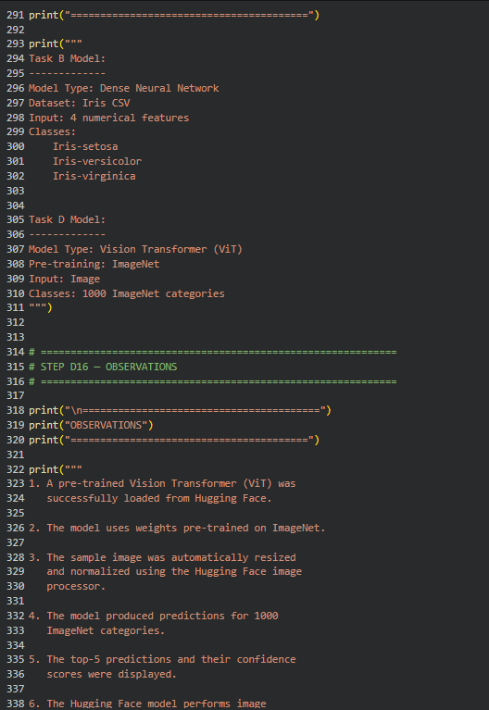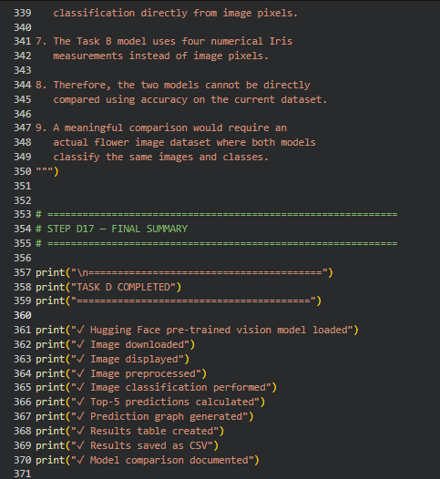

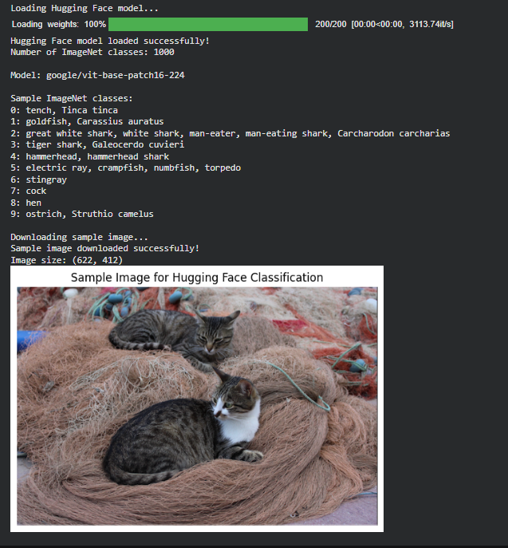
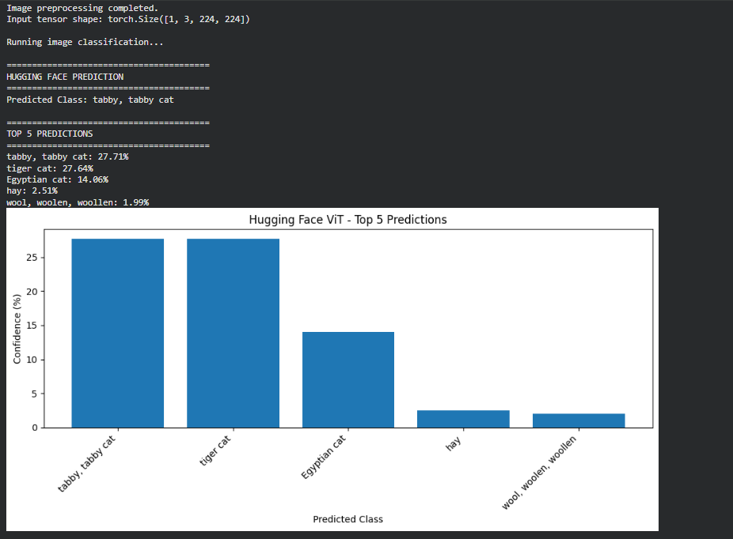
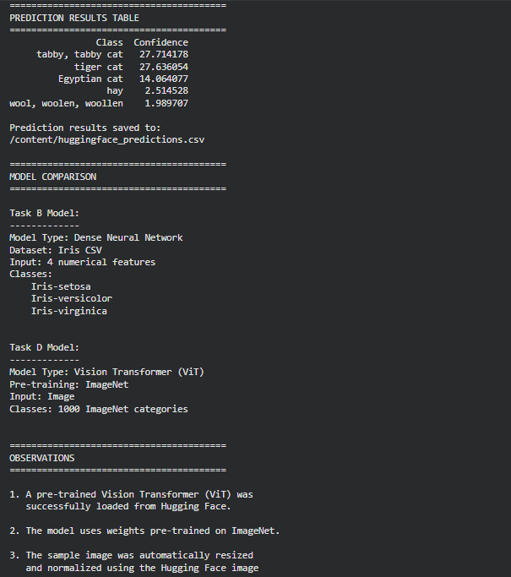
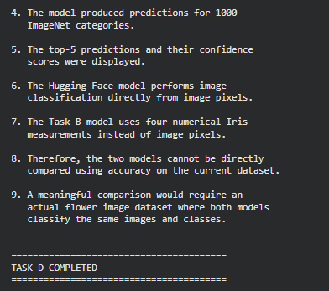

POST-LAB QUESTIONS (PROVIDE BRIEF ANSWERS TO THE FOLLOWING QUESTIONS)

  - What are the advantages of transfer learning compared to training a CNN from scratch?

Transfer learning uses knowledge learned from a large dataset such as ImageNet, so less training data and computational power are required. It reduces training time and usually provides better accuracy than training a CNN from scratch. It is especially useful when the available dataset is small.

  - Why are pre-trained models able to achieve higher accuracy with fewer training epochs?

Pre-trained models already contain useful features such as edges, textures, shapes, and patterns learned from large datasets. Therefore, they do not need to learn these basic features again. Only the task-specific classification layers usually need to be adapted, allowing the model to achieve good accuracy in fewer epochs.

  - Compare the performance of the transfer learning model with the CNN implemented in the previous experiment.

The transfer learning model generally achieves higher validation and test accuracy with less training compared with a CNN trained from scratch. It also tends to converge faster because it starts with learned features. However, the actual performance depends on the dataset, model architecture, and training settings.

  - What is the purpose of freezing layers during transfer learning?

Freezing layers prevents their pre-trained weights from being changed during the initial training stage. This preserves the useful features learned from the original dataset while the new classification layers are trained. It also reduces training time and helps prevent overfitting when the new dataset is small.

  - How can Hugging Face simplify the deployment and experimentation of vision models?

Hugging Face provides ready-to-use pre-trained vision models, processors, and standardized APIs. This allows developers to load and test advanced models with only a few lines of code instead of implementing them from scratch. It also makes experimentation, model sharing, and deployment easier.

ASSESSMENT
Description | Max Marks | Marks Awarded
Pre Lab Exercise | 5
In Lab Exercise | 10
Post Lab Exercise | 5
Viva | 10
Total | 30
Faculty Signature

